### **Probability and Statistics - IT2120 Lab – 05**

Ekanayake E.M.B - IT24101737

1).









2).

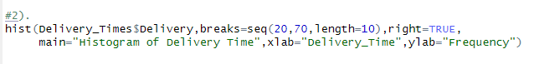

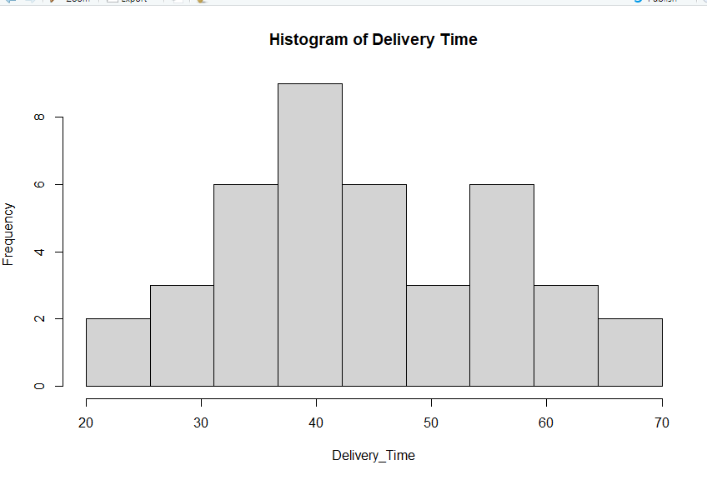

3). Shape: The distribution is roughly bell-shaped (unimodal) with most delivery times clustering around the middle around 35–45 minutes.

Symmetry: It appears fairly symmetric, with frequencies tapering off on both sides of the central peak.

Spread: Delivery times range from about 20 minutes to 70 minutes.

In this histogram, the bars are highest in the middle (around 40), and the left side (20–30) and right side (60–70) drop down almost evenly.

So the shape is approximately normal not strongly skewed.

Peaks: The highest frequency occurs near 40 minutes.

4).

